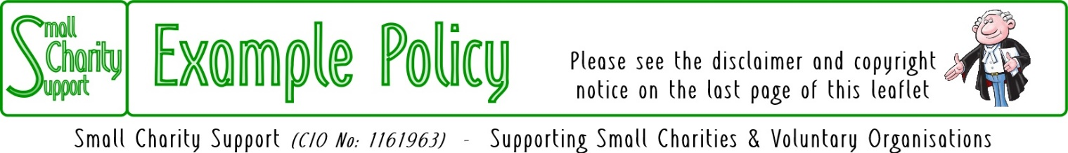
Last updated: 12-Apr-21

Code of Behaviour

Principles
As an adult working in Small Charity Support – whether as a member of staff or a volunteer – you have a responsibility to ensure that everyone attending Small Charity Support's activities, particularly children, young people and vulnerable adults, are protected from harm. It is the responsibility of each adult working in Small Charity Support to ensure that:
- their behaviour is appropriate at all times;
- they observe the rules established for the safety and security of children, young people and vulnerable adults;
- they follow the procedures following suspicion, disclosure or allegation of child abuse;
- the recognise the position of trust in which they have been placed; and
- in every respect, the relationships they form with the children, young people and vulnerable adults in their care are appropriate
All persons who wish to work in Small Charity Support, must accept and understand this policy. They must also agree to put Small Charity Support’s policies on safeguarding children and vulnerable adults into practice.

Meeting your responsibilities
To give positive guidance the Code of Behaviour (below) provides a list of 'do's and don'ts' to help you ensure that:
- the welfare of the children and/or young people and/or vulnerable adults for whom you have a duty of care is safeguarded;
- you avoid compromising situations or opportunities for misunderstandings or allegations.

Code of behaviour
- DO put this code into practice at all times;
- DO treat everyone with dignity and respect;
- DO set an example you would wish others to follow;
- DO treat all young people equally - show no favouritism;
- DO plan activities that involve more than one other person being present, or at least are within sight and hearing of others;
- DO follow recommended adult/young people ratios for meetings and activities;
- DO respect the right to personal privacy of a child, young person or vulnerable adult;
- DO avoid unacceptable situations within a relationship of trust, eg: a sexual relationship with a young person or vulnerable adult over the age of consent;
- DO have separate sleeping accommodation for children, young people, adults and Young Leaders working with a younger Section in any overnight activity;
- DO allow children, young people and vulnerable adults to talk about any concerns they may have;
- DO encourage others to challenge any attitudes or behaviours they do not like;
- DO avoid being drawn into inappropriate attention seeking behaviour, eg: tantrums and crushes;
- DO follow Small Charity Support's 'no alcohol' guidance;
- DO make everyone aware of Small Charity Support's procedures for safeguarding children, young people and vulnerable adults;
- DO remember this code even at sensitive moments, eg: when responding to bullying, bereavement or abuse;
- DO keep other members of staff/volunteers informed of where you are and what you are doing;
- DO remember someone else might misinterpret your actions, no matter how well-intentioned;
- DO take any allegations or concerns of abuse seriously and refer immediately.

  - DO NOT trivialise abuse;
  - DO NOT form a relationship with a child, young person or vulnerable adult that is an abuse of trust;
  - DO NOT permit abusive peer activities, eg: initiation ceremonies, bullying;
  - DO NOT engage in inappropriate behaviour or contact - physical, verbal, sexual;
  - DO NOT play physical contact games with children, young people or vulnerable adults;
  - DO NOT make suggestive remarks or threats to a young person, even in fun;
  - DO NOT use inappropriate language - writing, phoning, email or internet;
  - DO NOT let allegations, suspicions, or concerns about abuse go unreported;
  - DO NOT just rely on your good name to protect you.

Change Record
Date of Change: | Changed By: | Comments:
xx/xx/xx | XX | Policy approved by the Trustees

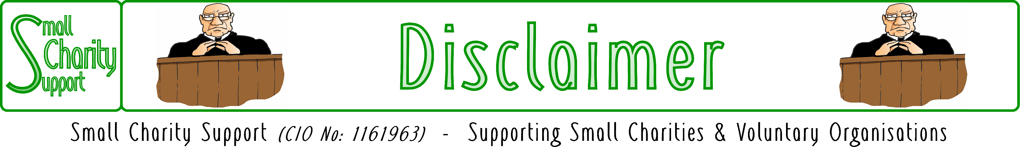

While it is Small Charity Support’s intention to provide you
with the best possible support and information as we are able,
it is important that you read and give due consideration
to the following notices.

The information contained in this leaflet is provided in summary form and is made available for general information purposes only. It has not been prepared with your specific needs in mind and is not advice of any kind (whether legal, financial, or otherwise).
Please take the time to check the information in this leaflet is suited to your specific circumstances and if you are making any important decisions, such as on financial, legal or tax matters, you should consult a qualified professional adviser who can provide specific advice based on your position.
Small Charity Support does not assume any liability or responsibility to any person or entity for the information contained in this leaflet and you should not rely on any information contained in this leaflet. Small Charity Support makes no representation as to, and does not assume any responsibility for, the accuracy, completeness or relevance of the information contained in this leaflet.
Please make sure that any sites you link to from this leaflet (or on our website) are appropriate to you, as we do not endorse such websites and have no control over their contents or how (or if) that site operates. Any links or references in this leaflet to a company, entity, service or product does not, in any way, imply an endorsement.

© 2021 Small Charity Support
This leaflet is made available to charities and not-for-profit organisations under a
Creative Commons Attributable – Non Commercial – Share Alike International 4.0 License
That license lets you remix, adapt, and build upon this material non-commercially, as long as you credit Small Charity Support and license your new creations under the identical terms.

