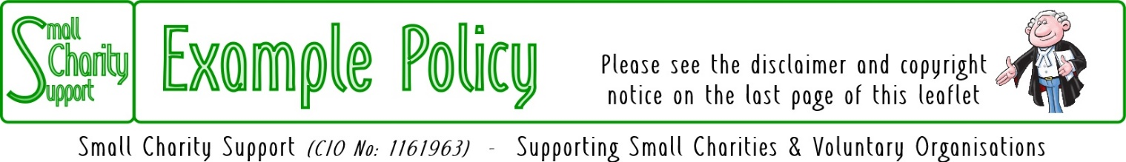
Last updated: 12-May-24

Participants: Personal Data

Key to Legal Basis for processing: We hold the following personal information about you in accordance with the EU General Data Protection Regulation (GDPR) and the Policy Notice overleaf.

LI=Legitimate Interest; this is the basic information that we have to keep about you in order to invite and welcome you to our activities.

SC=Subject Consent; providing this information is optional. But if you consent to give us this information it will make it easier for us to plan our activities for your convenience and benefit.
 |  | LI | SC
Title: | Optional:
Given Name(s)
Family Name
Preferred Name | Optional:
Date First participated  Last participated | You do not need to complete this box.  We will keep our own records of this information
Address Street address
Address line 2, if required
Town/City
Post/Zip Code
Phone Number(s) | Optional:
E-mail Address(es) | Optional:
Subscriptions that you pay and any donations that you make | You do not need to complete this box.  We will keep our own records of this information
Personal Experience, Expertise & Interests | Optional:
Special Needs | Optional:

I confirm that I am happy for the Charity to hold my above personal data and to use it for the purposes described in the Privacy Notice overleaf.

Signed: ……………………………………………………… Date: ……/……/.202…..

Privacy Notice: Participants in Activities
It is important to us that you understand and are happy with how we use your information.
Please take time to read this Privacy Notice in full.

Data Subjects
are people like you, who take part in our activities.

What we do with your personal data?
We use your personal data to help us organise the sort of activities that you like to come to, and to keep you informed about those activities. We can do this because we have a legitimate interest in knowing who is participating in our activities and in being able to share with them details of our activities (including any changes) and related activities.
Additional optional information we only keep and use with your consent.

Your right to withdraw consent at any time
You can tell us that you no longer wish us to use your data in this way and, if you do, we must stop using it as soon as is reasonably practical

Your right to require the erasure of your data (right to be forgotten)
If you no longer wish us to have or use your data you can tell us to remove your data completely from our records and we must do so as soon as is reasonably practical

Who gets to see your personal data?
We only share your personal data with other people when it is necessary to do so in order for us to run our activities efficiently and in the way that you would like.
We do not share your data with anyone else.

How long do we keep your personal data?
We only keep your personal data while you come to our activities, either regularly or from time-to-time.
If we have not seen you at one of our activities for 2 years we will delete your data.

We do not transfer your personal data to other countries

The existence of each of your rights
Under the General Data Protection Regulation you have the following rights:
                - to be told about what data we have, how and what we use it for, and who we share it with (as we are doing in this Privacy Notice);
                - to be given access to your personal data;
                - to have any errors corrected or incomplete data completed;
                - to stop us using your data if you think our use is unjustified or the data are inaccurate.

Your legal obligation
You are under no legal obligation to give us your personal data if you do not wish to.

The existence of automated decision making, including profiling
The Charity does not use computers to analyse your data in order to make computer decisions about what communications the charity should, or should not, send to you.

The right to complain to the UK Information Commissioner’s Office:
if you are dissatisfied with the way that the Charity is collecting, holding, processing and using your personal data you are entitled to complain to the Information Commissioner.

Identity and contact details of the controller.
The Charity’s Data Controller is the Principal Trustee.
The Controller can be contacted via: The Lead Trustee, Small Charity Support,
11 High Street, Anyborough, LONDON AB1 2HS
Phone: 020-1234 9876; e-mail: Enquiries@smallcharitysupport.uk
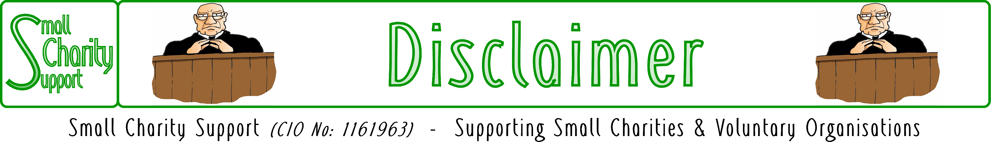

While it is Small Charity Support’s intention to provide you
with the best possible support and information as we are able,
it is important that you read and give due consideration
to the following notices.

The information contained in this leaflet is provided in summary form and is made available for general information purposes only. It has not been prepared with your specific needs in mind and is not advice of any kind (whether legal, financial, or otherwise).
Please take the time to check the information in this leaflet is suited to your specific circumstances and if you are making any important decisions, such as on financial, legal or tax matters, you should consult a qualified professional adviser who can provide specific advice based on your position.
Small Charity Support does not assume any liability or responsibility to any person or entity for the information contained in this leaflet and you should not rely on any information contained in this leaflet. Small Charity Support makes no representation as to, and does not assume any responsibility for, the accuracy, completeness or relevance of the information contained in this leaflet.
Please make sure that any sites you link to from this leaflet (or on our website) are appropriate to you, as we do not endorse such websites and have no control over their contents or how (or if) that site operates. Any links or references in this leaflet to a company, entity, service or product does not, in any way, imply an endorsement.

© 2021-2024 Small Charity Support
This leaflet is made available to charities and not-for-profit organisations under a
Creative Commons Attributable – Non Commercial – Share Alike International 4.0 License
That license lets you remix, adapt, and build upon this material non-commercially, as long as you credit Small Charity Support and license your new creations under the identical terms.

